SQL Server Integration Services

# Module 02: Getting to know ssdt

1. Launch SQL Server Data Tools (SSDT), under start menu look for Visual Studio 2017 (SSDT).
2. In the Start Page, click Create new project.  
   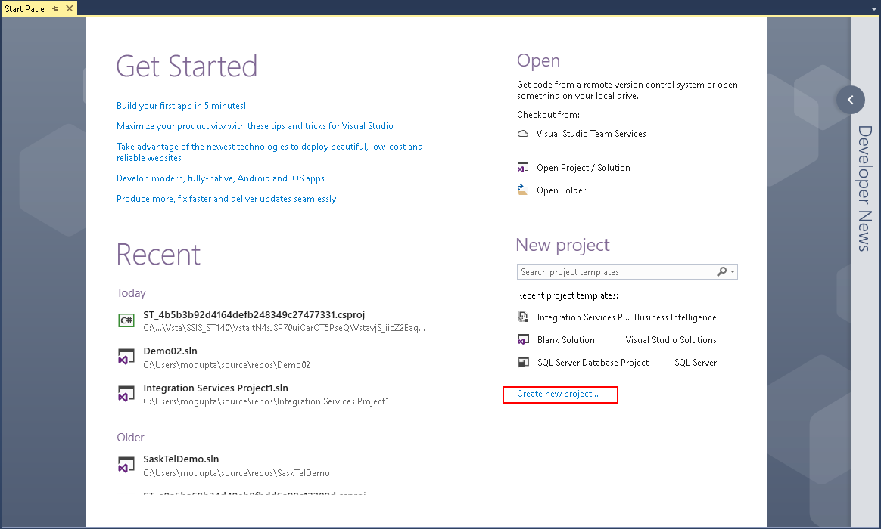
3. In New Project dialog box select Business Intelligence > Integration Services > Integration Services Project. On the bottom enter in project name and location you wish to save the project. Make sure “Create directory for solution” is selected and click OK.

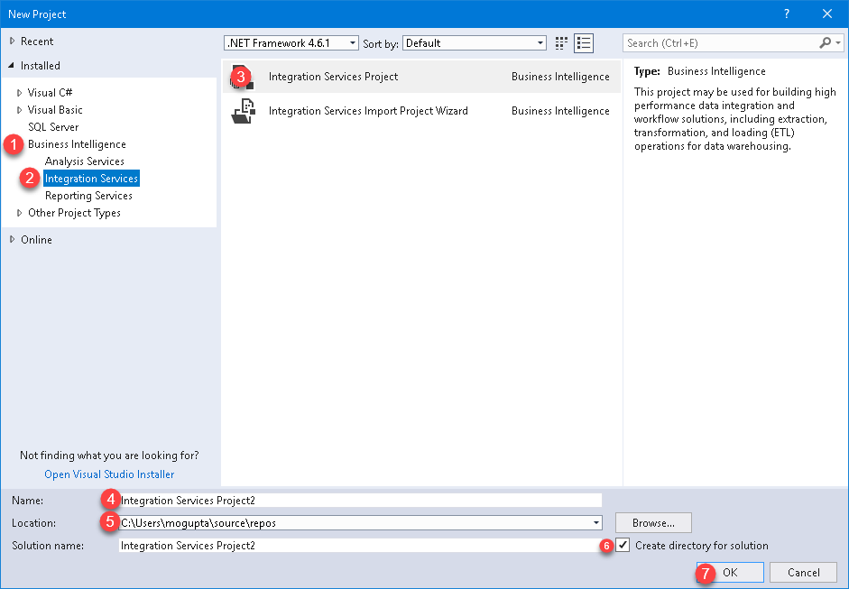

1. In the new designer explore various options available to you:
   1. SSIS Toolbox (Left). Experiment with dragging and dropping few tasks on the designer window. Drop data flow task to explore the tasks inside data flow. Double-click tasks dropped to look at their respective properties. Can you explain why these tasks are marked with the alert (not-configured)?  
      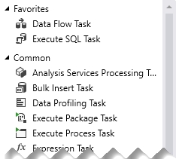
   2. Designer (Center Top). Review each of the tabs. Create tasks in Control Flow and Data Flow, review changes in Package Explore.   
      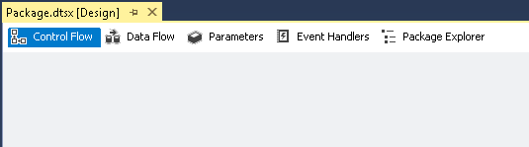
   3. Connection Manager (Center Bottom). Create a connection in package and create a connection in Project; what is the difference?



* 1. Solution Explorer (Right). Look at properties of the project, see if you change the deployment context.  
     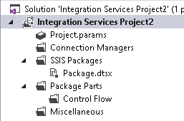
  2. In Package Explorer, explore various folders. What does each folder mean?

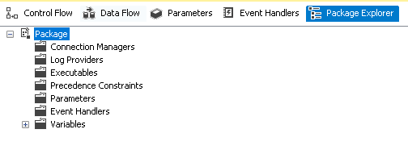

* 1. SSIS Menu, is your one stop shop for all the SSIS package development functionality. It is interesting to note you can access same functionality in view menu, keyboard shortcuts, SSIS menu, and the quick access bottoms in designer screen.  
     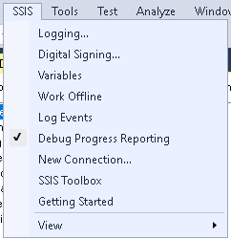

1. After you are done exploring (if you don’t understand all the options its okay, we’ll explore them in later labs). Let’s build a simple package and execute it. Start by cleaning the designer by deleting all the tasks you might have copied.
2. Then dropping a “Execute SQL Task” under SSIS Toolbox under Favorites on to designer – So you should only have single task under Control Flow.  
   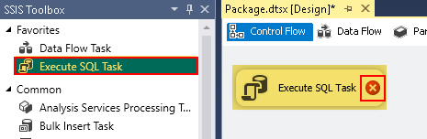
3. After you drop it, notice there is a white “x” in a red circle. This is an indication, we need to do configuration on the task. Double-click on the task. Click on the drop down by Connections and select <New connections…>.  
   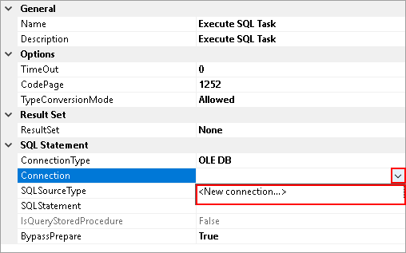
4. In Configure OLE DB Connect Manager, click New.  
   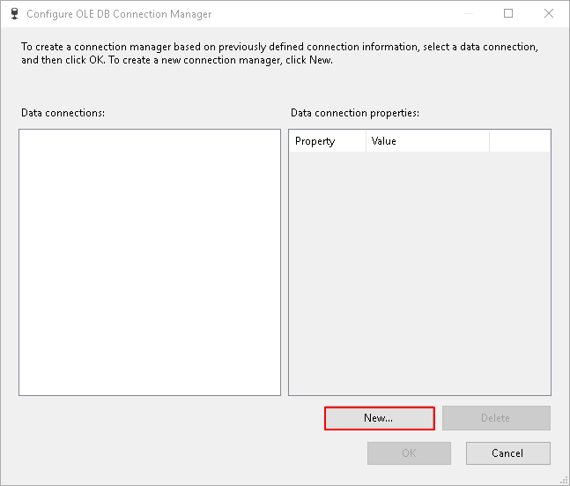
5. In connection manager, type the server name, select the database “AdventureWorks2012” and click OK.  
   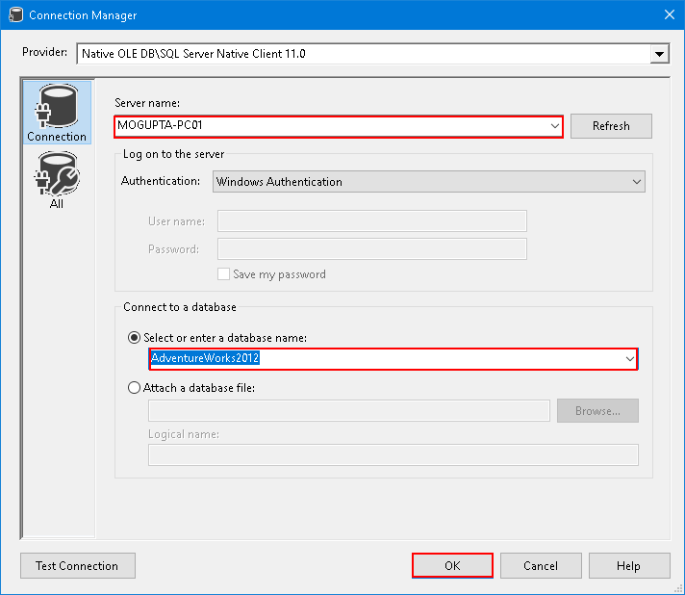
6. Click OK in Configure OLE DB Connection Manager.
7. Next click on SQLStatement and click on the ellipse beside it.  
   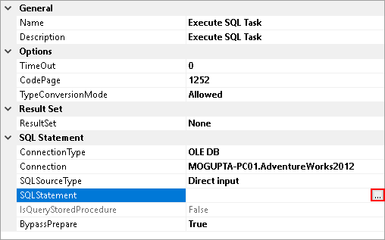
8. Type in following select statement and click OK.  
   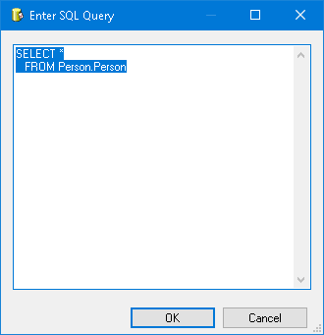
9. Click OK in the Execute SQL Task Editor, notice the alert is gone.
10. Click on “Start” or Press F5 to execute the package. Once execute properly it should return with green checkbox and you’ll have a new tab called progress. Click on it.  
    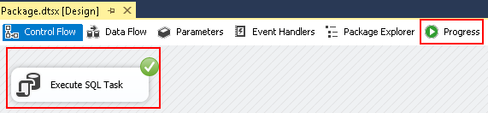
11. Review the output of the progress, to understand how long the task took to complete. This can be helpful in understand where the time is being spent in larger and more complex packages.  
    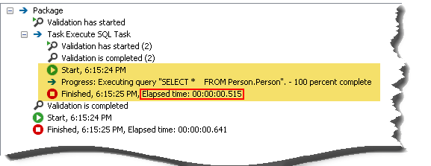
12. Click on “Stop”, Red Square button on the tool to stop.